**Web Engineering Lab**

SEL-310

***Lab Journal***



**Student Name**

**Enrolment No.**

**Class and Section**

**Department of Computer Science**

**BAHRIA UNIVERSITY, ISLAMABAD**

**Lab # 5 Bootstrap**

**Objectives:**

**Understanding the responsive websites with the implementation of Bootstrap.**

**Tools Used: Visual Studio**

**Submission Date:**

**Evaluation: Signatures of Lab Engineer:**

**Task # 5.1:** Design the following task using HTML tags and CSS properties with bootstrap. Consider a Real Estate website having 5 pages; Home, Search, Buy, Sell, About Us and Contact Us.(Don’t create other pages. Just design the home page)

* Create the Home page for this Real Estate website.
* Use the .container class
* Create the Menu/Navigation for the home page which will include; Home, Search, Buy, Sell, About Us and Contact Us links.
* Create a listing on home page having Property image, Price, Status, address and a Details button or a link
* Two column layout for Customer reviews and Advertisements.
* Footer is also included having company details and social icons.
* Make this webpage responsive website.
* Following is the design sample for the home page.

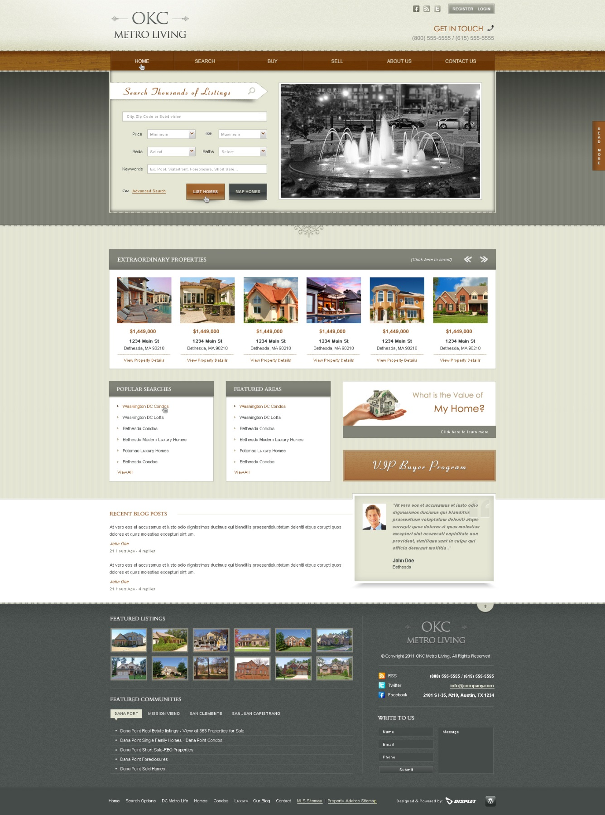

**Procedure/Program:**

**Result/Output:**

**Analysis/Conclusion:**